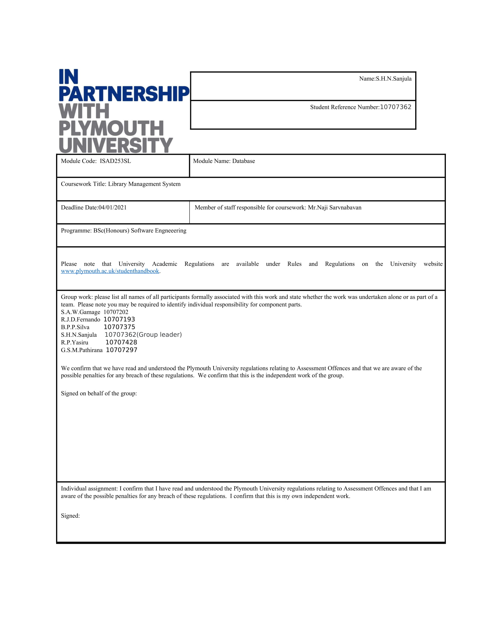

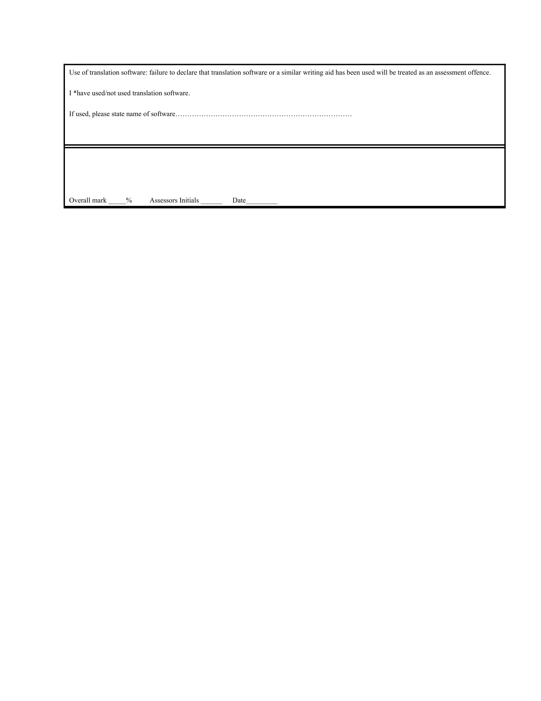

Table of Contents

Introduction 4

ER Diagram 4

Assumptions 4

Relational Schema 5

Data Dictionary 6

Sql statements 8

Data Normalization 15

Database Diagram 17

Views 18

Procedures 20

Triggers 21

Fuctions 22

# Introduction

Lanka library is a library service chain which is very poular in Sri Lanka.They offer many services such as keeping book records,book copy,records,l,borrowers records ,loan records.Lanka library needed a good database to maintain their records and provide good user experience to their library service.they want to track their records which contains Book,copy,borrower,loan etc. Introducing new Data Base Management System which maintain details about library, bookcopy, Borrower, Branches, Loan,and other details.

# ER Diagram

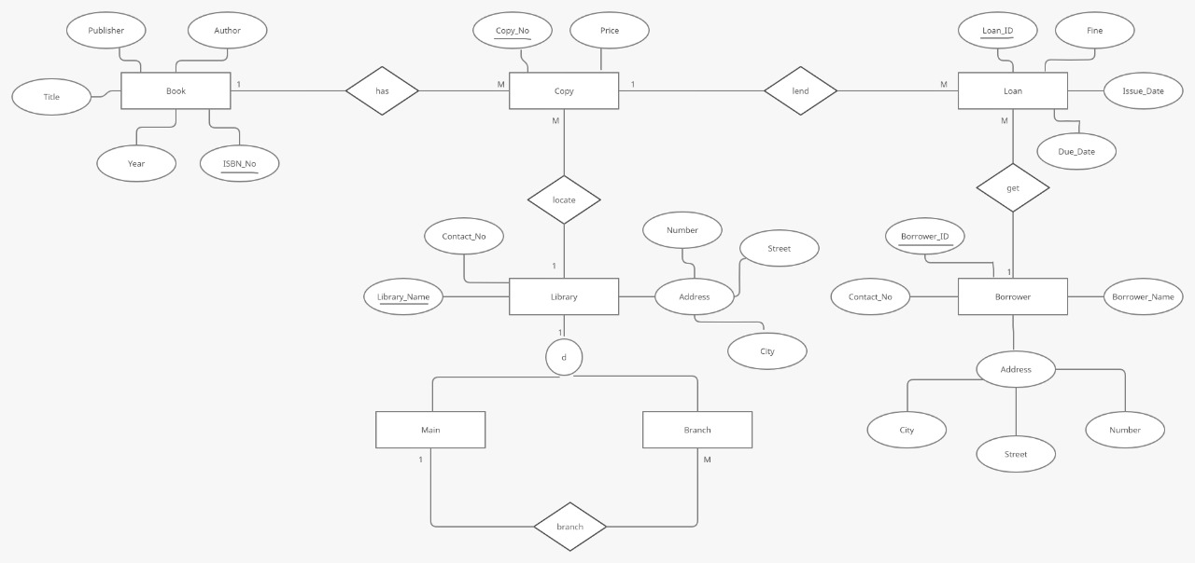

# Assumptions

* One book has many copies
* One borrower can loan several books
* Address in Borrower is a composite attribute
* Library has only one main branch
* Library can have many branches
* Primary key of book entity is ISBN_NO
* Primary key of Book entity is ISBN_NO
* Primary key of Copy entity is Copy_NO
* Primary key of Loan entity is Loan_ID
* Primary key of Borrower entity is Borrower_ID

# Relational Schema

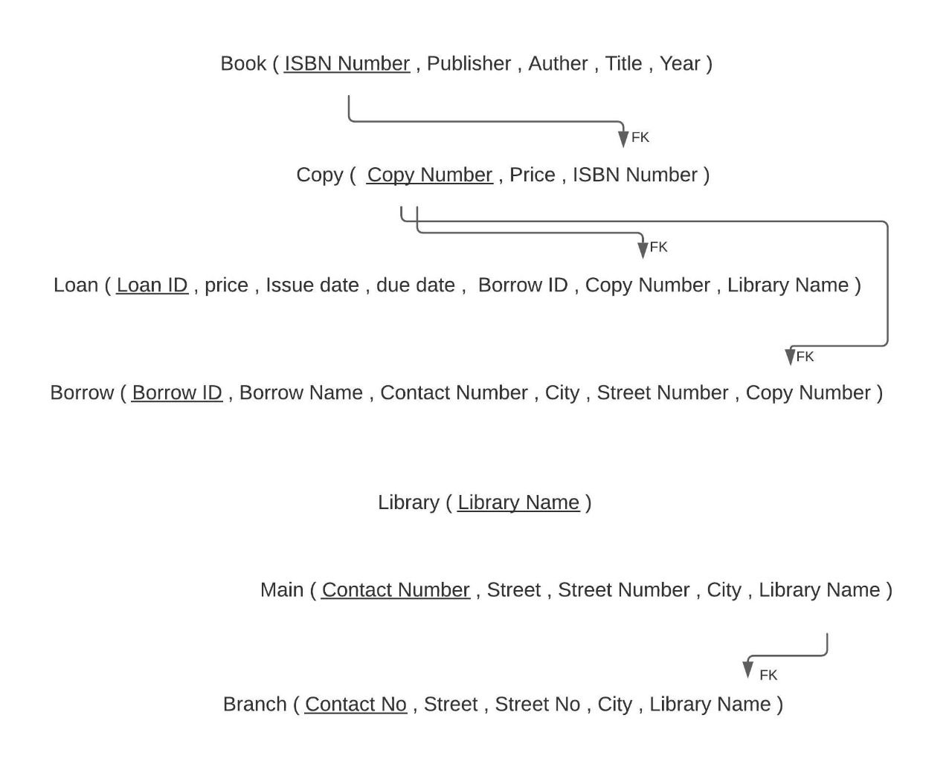

# Data Dictionary

**Book Table.**

|  |  |  |  |
| --- | --- | --- | --- |
| Fieldname | Datatype | Field length | Description |
| ISBN_No | Char | 20 | Not NULL, Primary Key |
| Publisher | Varchar | 50 | Not NULL |
| Author | Varchar | 40 | Not NULL |
| Title | Varchar | 40 | Not NULL |
| Year | Date | - | Not NULL |

**Copy Table.**

|  |  |  |  |
| --- | --- | --- | --- |
| Fieldname | Datatype | Field length | Description |
| Copy_No | Char | 20 | Not NULL, Primary Key |
| Price | money | 06 | Not NULL |

**Loan Table.**

|  |  |  |  |
| --- | --- | --- | --- |
| Fieldname | Datatype | Field length | Description |
| Loan_ID | Char | 20 | Not NULL, Primary Key |
| Fine | Char | 10 | Not NULL |
| Issue_Date | Date | - | Not NULL |
| Due_Date | Date | - | Not NULL |

**Borrower Table.**

|  |  |  |  |
| --- | --- | --- | --- |
| Fieldname | Datatype | Field length | Description |
| Borrower_ID | Char | 20 | Not NULL, Primary Key |
| Contact_No | Char | 10 | Not NULL |
| Borrower_Name | Varchar | 40 | Not NULL |
| City | Varchar | 20 | Not NULL |
| Street | Varchar | 30 | Not NULL |
| Number | Varchar | 10 | Not NULL |

**Library Table.**

|  |  |  |  |
| --- | --- | --- | --- |
| Fieldname | Datatype | Field length | Description |
| Library_Name | Varchar | 20 | Not NULL, Primary Key |
| Contact_NO | varchar | 20 | Not NULL |
| City | varchar | 20 | Not NULL |
| Street | varchar | 20 | Not NULL |
| Street Number | varchar | 20 | Not NULL |

# Sql statements

Sql statement for Book table

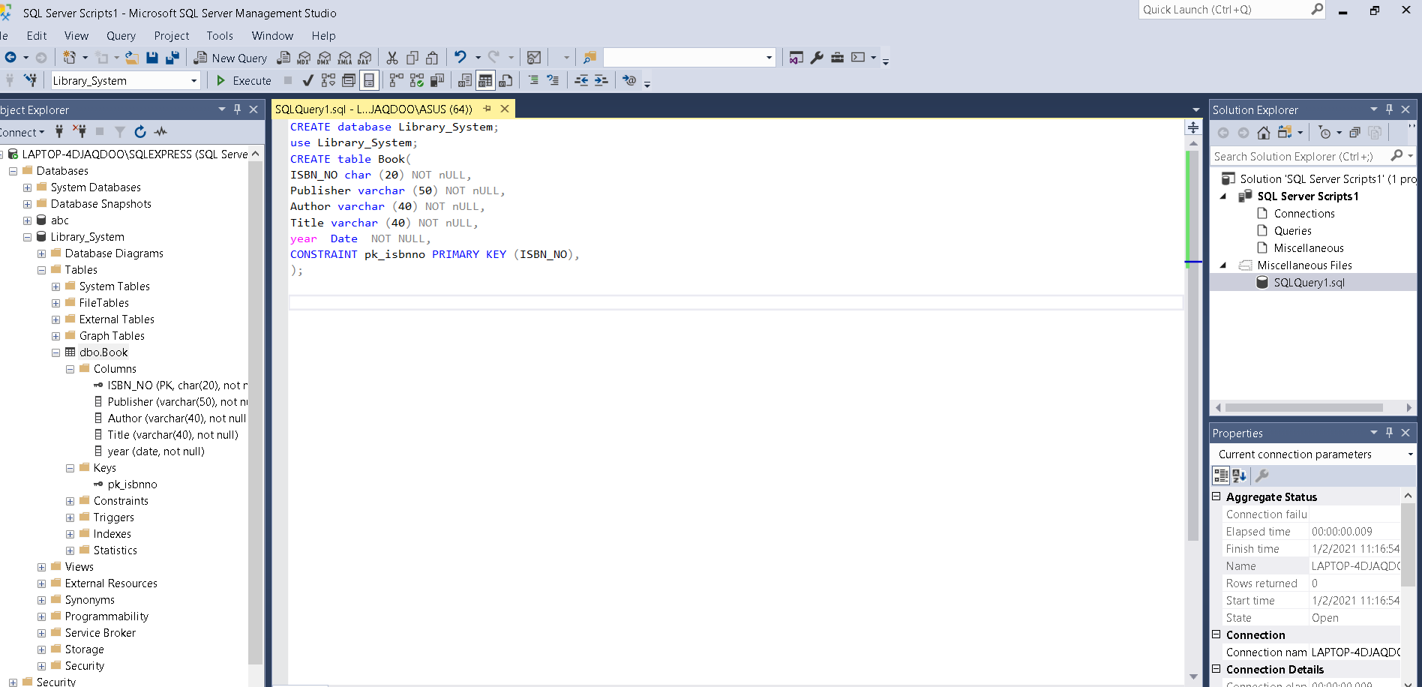

Sql statement for copy table

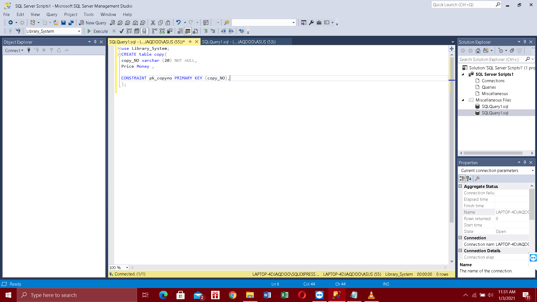

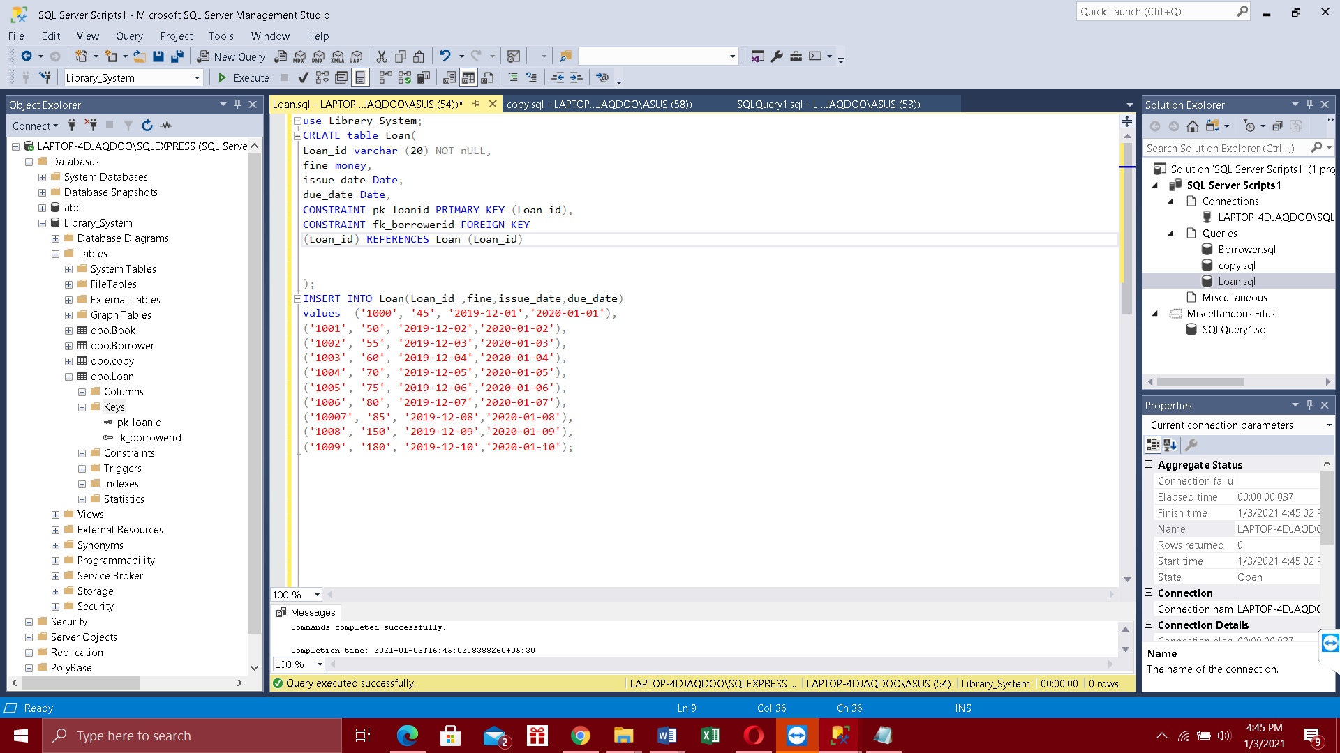Sql Statement for Loan table and data insertion

Sql statement for copy table data insertion

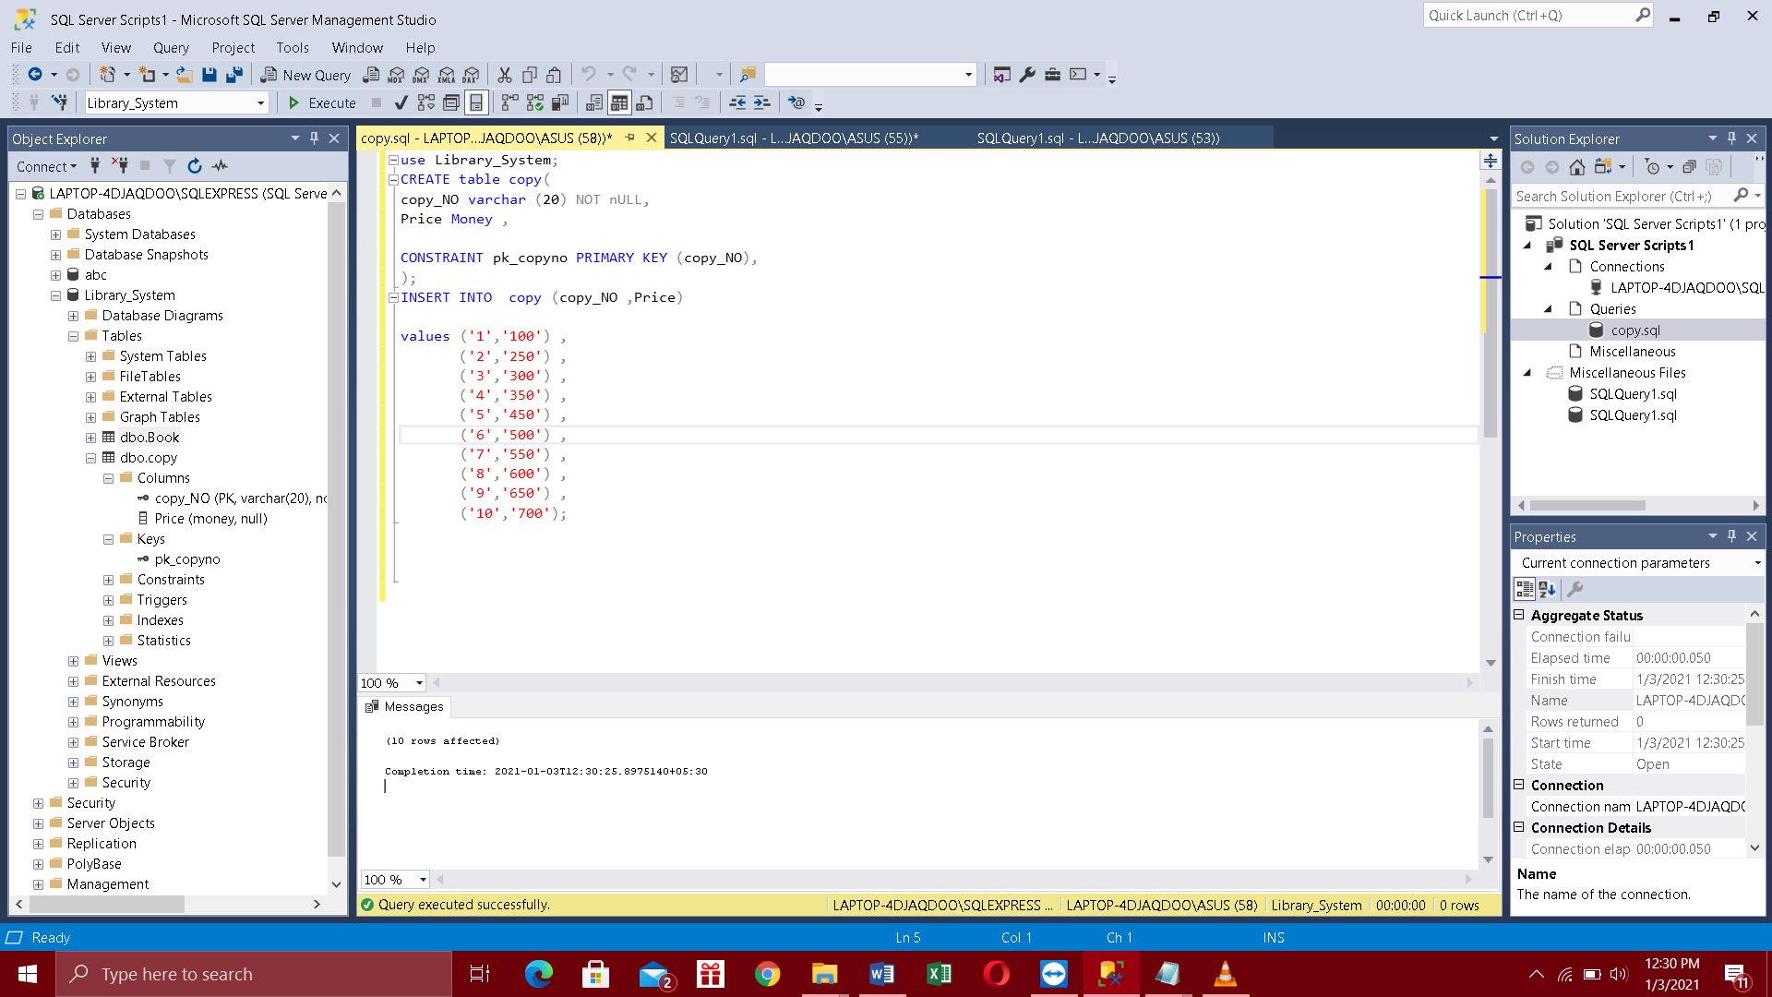

Sql Statement For Library Table

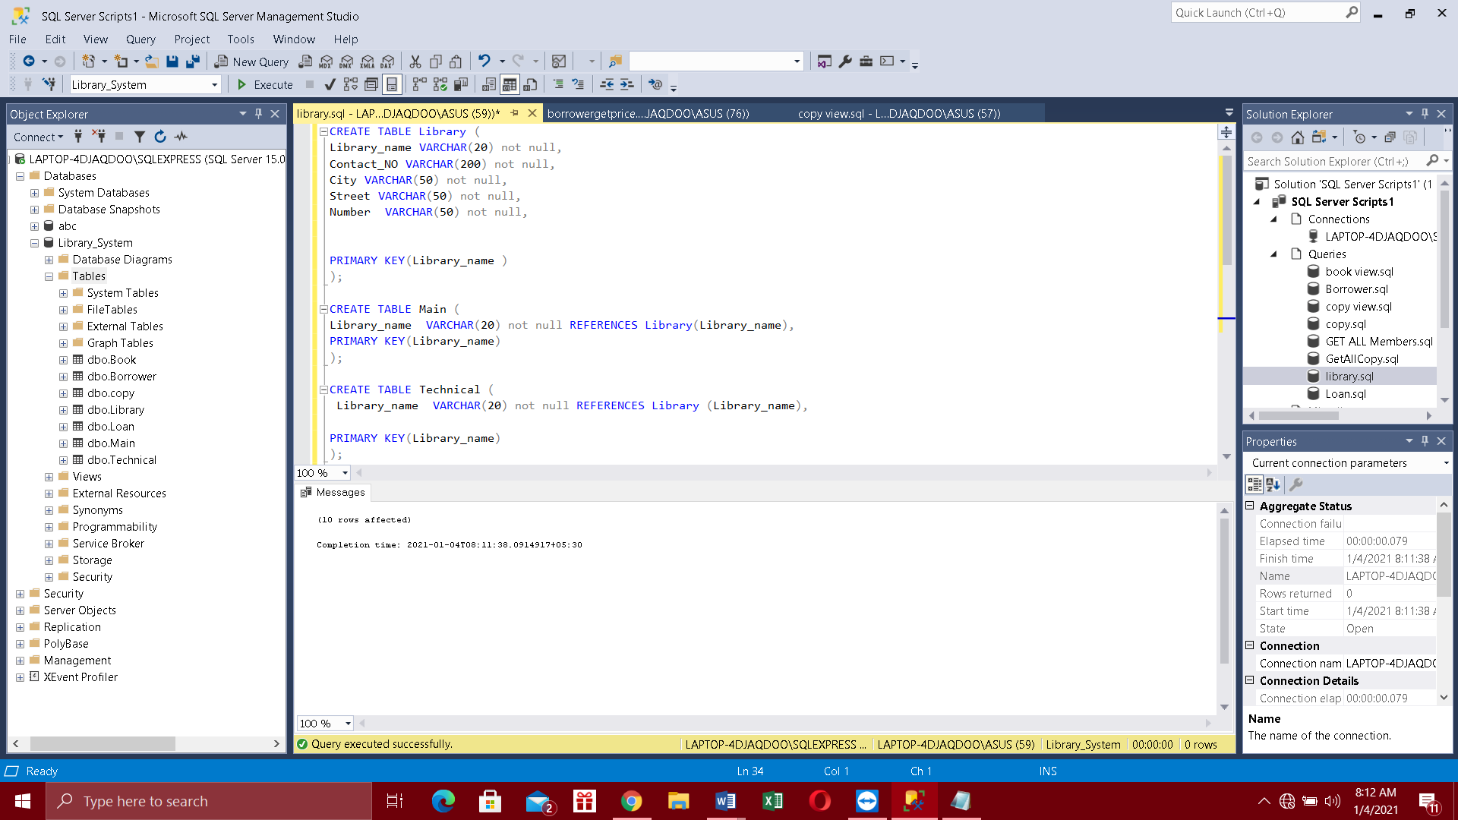

Inserting data into the Library table

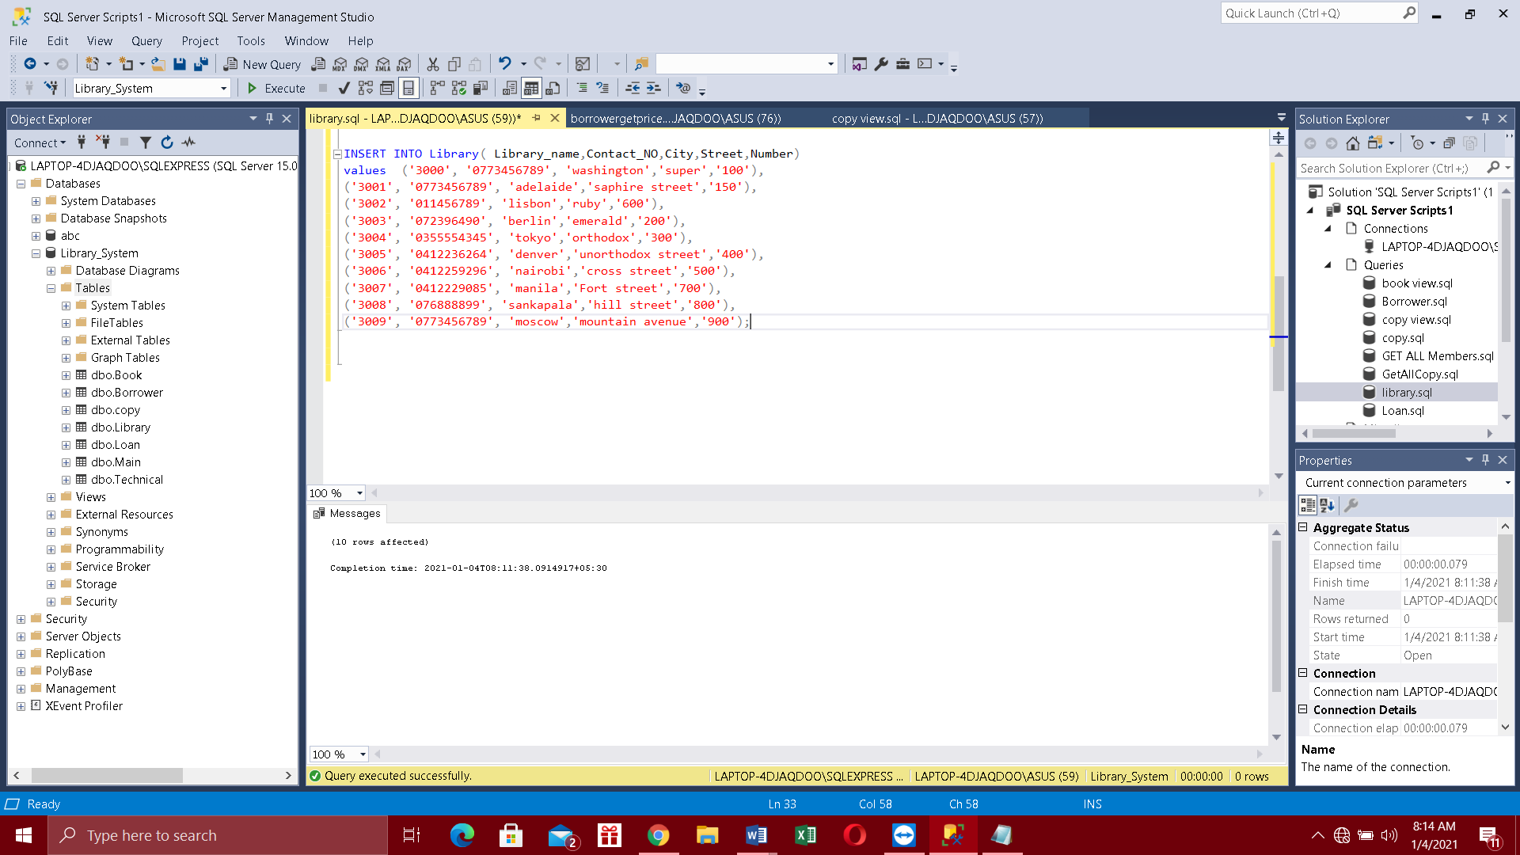Data in Library table

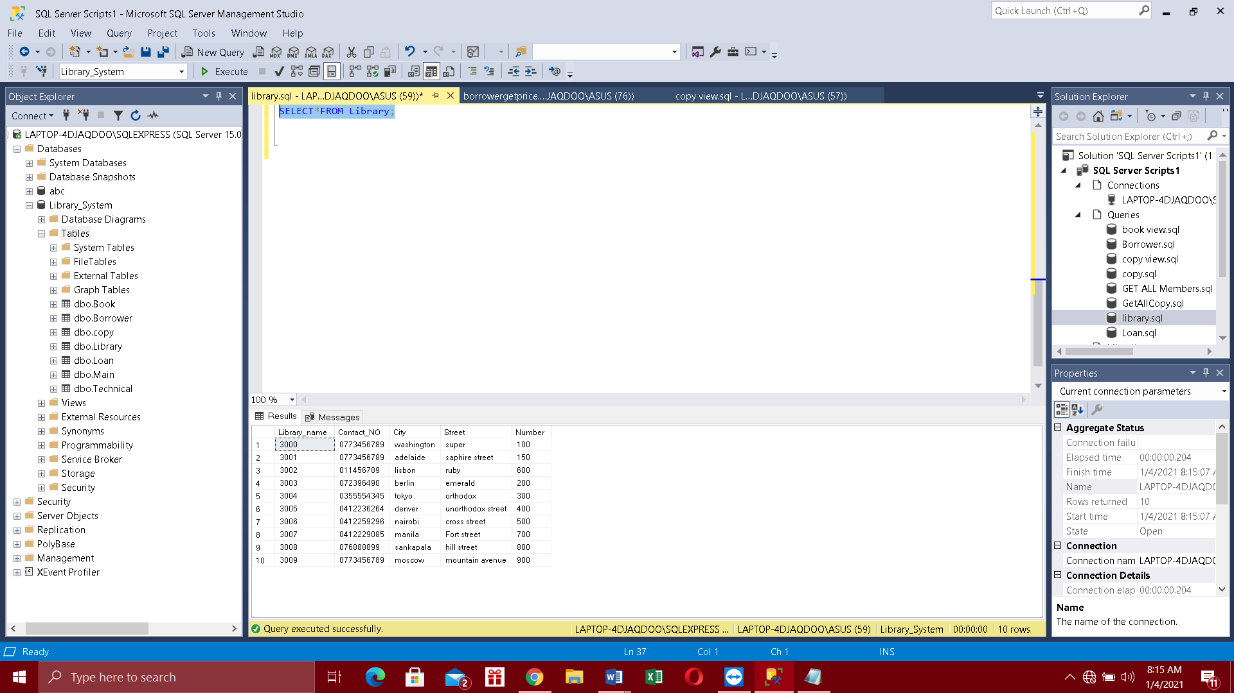

Data in Borrower table

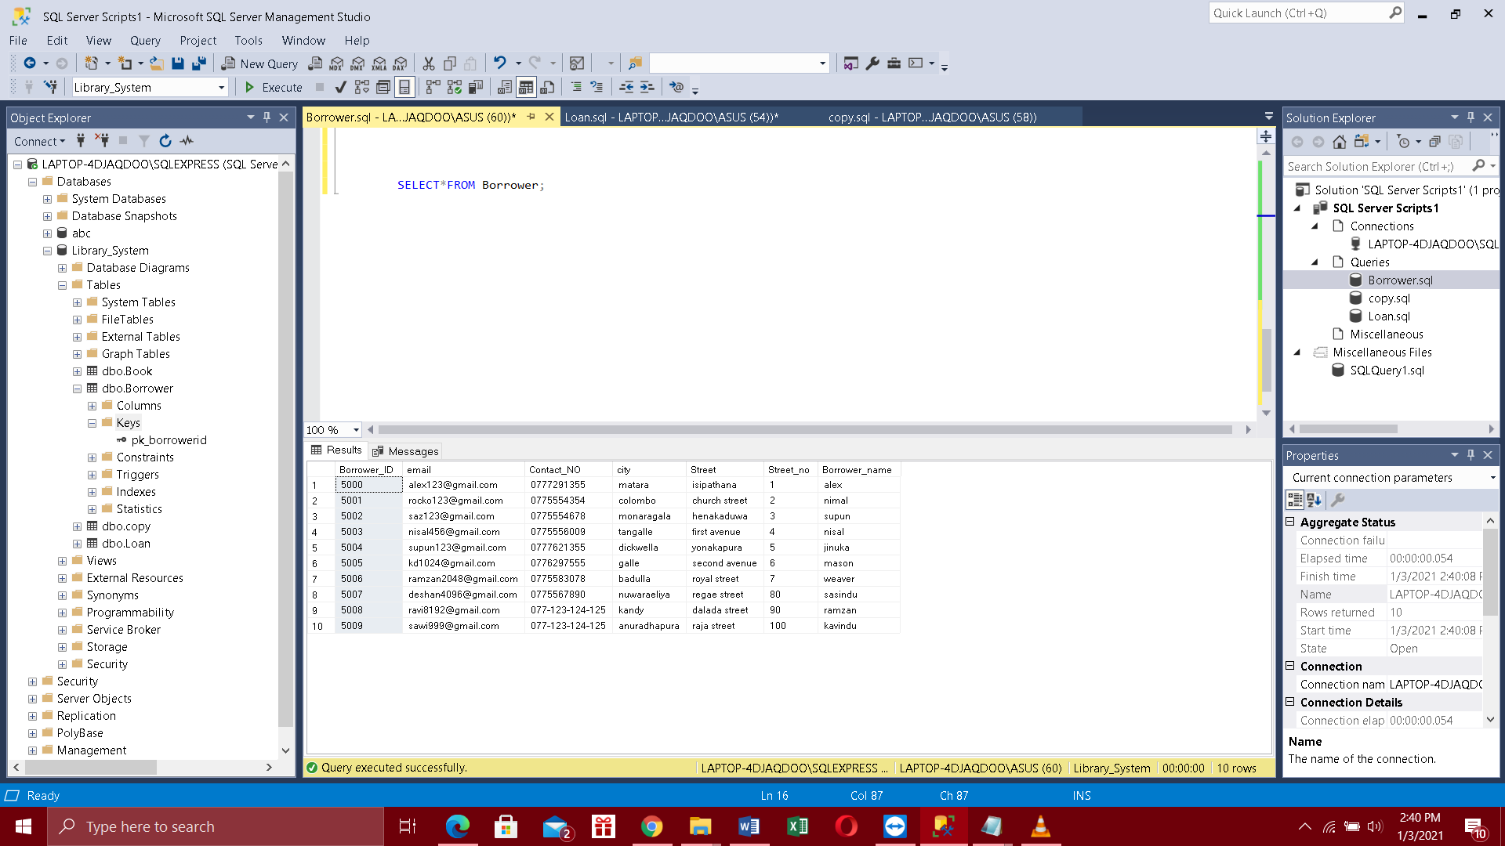

Datain copy table

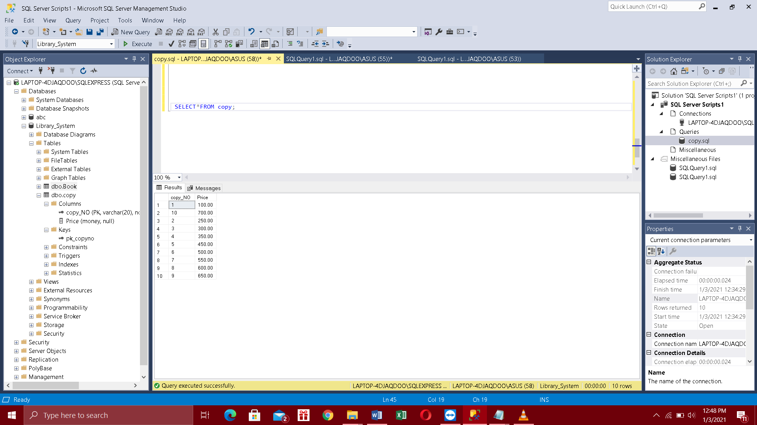

# Data Normalization

**Book Table.**

|  |  |  |  |
| --- | --- | --- | --- |
| Book_name | Book_id | Author | Title |
| Intro to Zoology | 001 | Nimal | book |
| Intro to Zoology | 001 | Nimal | novel |
| Intro to Zoology | 001 | Nimal | fiction |
| Administration affairs | **002** | Sunil | adventure |
| Biology | **003** | Kamal | Fiction |

1NF

In first normalization values should be atomic and single valued

|  |  |  |  |
| --- | --- | --- | --- |
| Book_name | Book_id | Author | Title |
| Intro to Zoology | 001 | Nimal | {book,Novel,Fiction} |
| Administration affairs | 002 | Sunil | {Adventure} |
| Biology | 003 | Kaamal | {Fiction} |

2nf

In Second normalization partial depedencies should be removed from the table

|  |  |  |  |  |
| --- | --- | --- | --- | --- |
| ISBN_NO | Author | Title | year | publisher |

ISBN title table

|  |  |  |
| --- | --- | --- |
| ISBN_NO | Author | year |

ISBN_NO year table

|  |  |
| --- | --- |
| ISBN_NO | year |

Author Year table

|  |  |  |
| --- | --- | --- |
| Author | year | publisher |

# Database Diagram

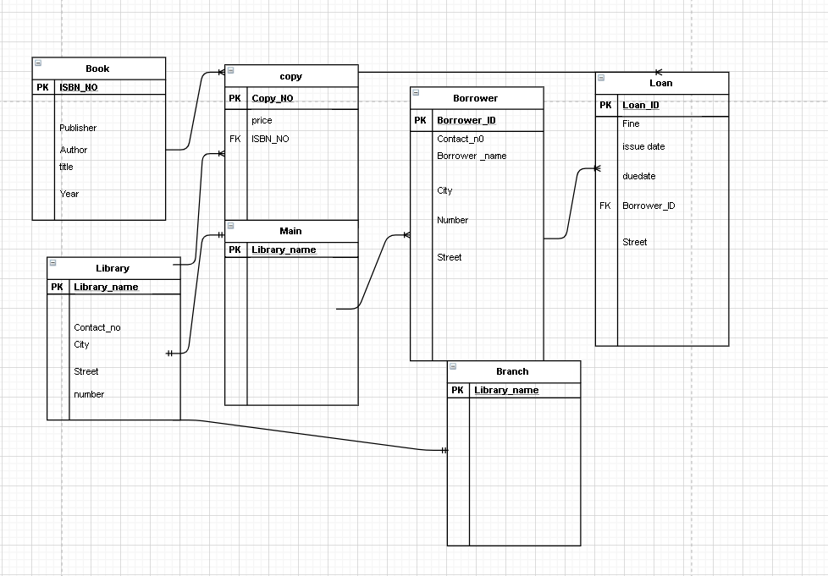

# Views

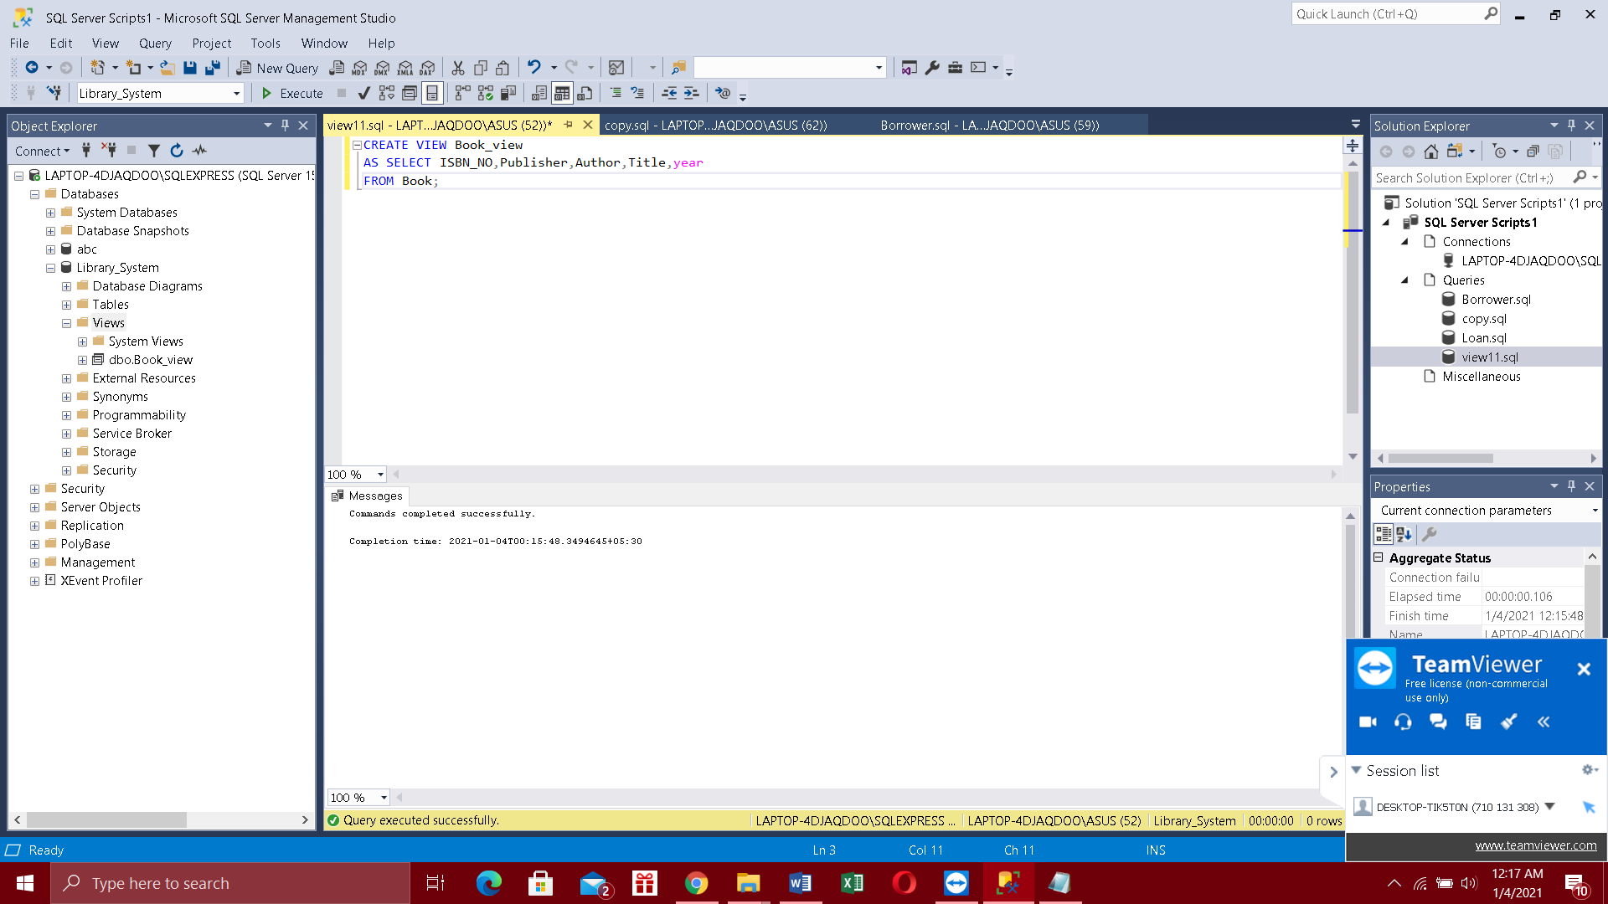

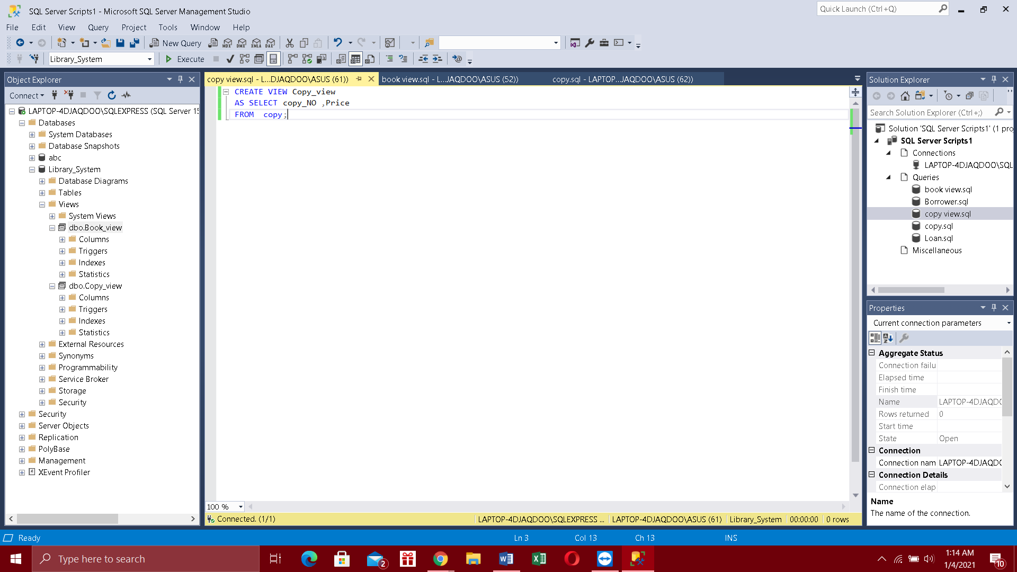

# Procedures

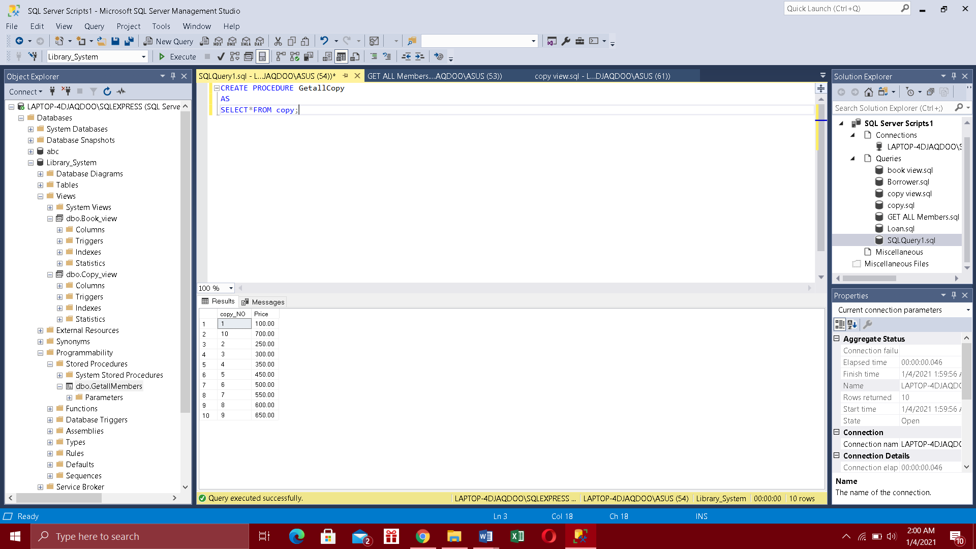

# Triggers

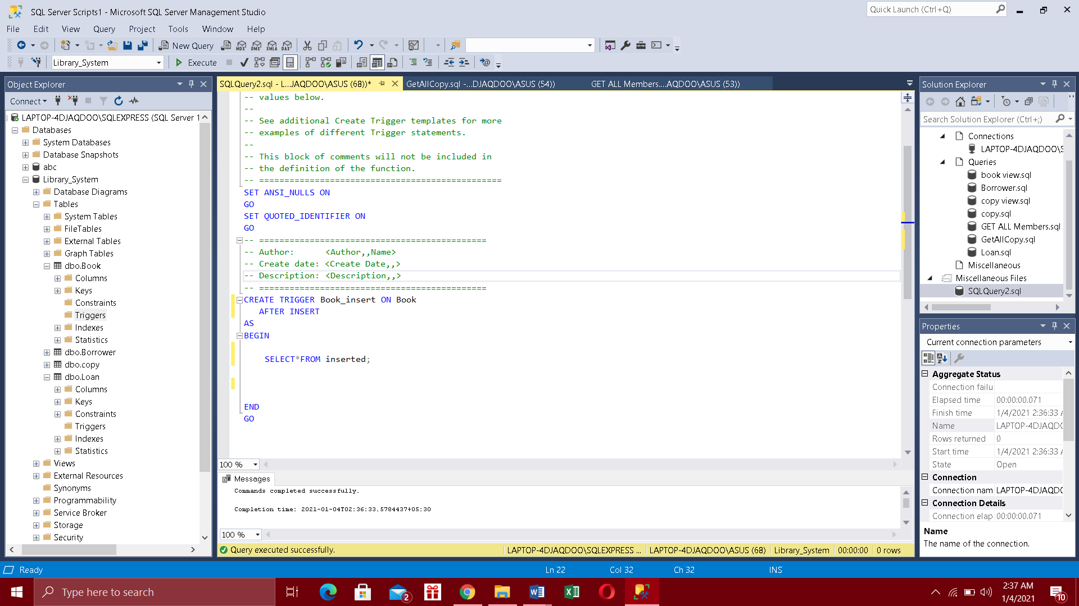

# Fuctions

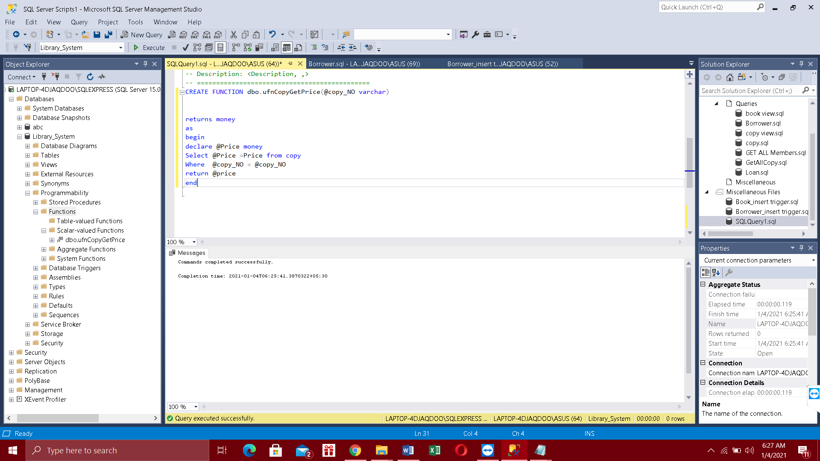

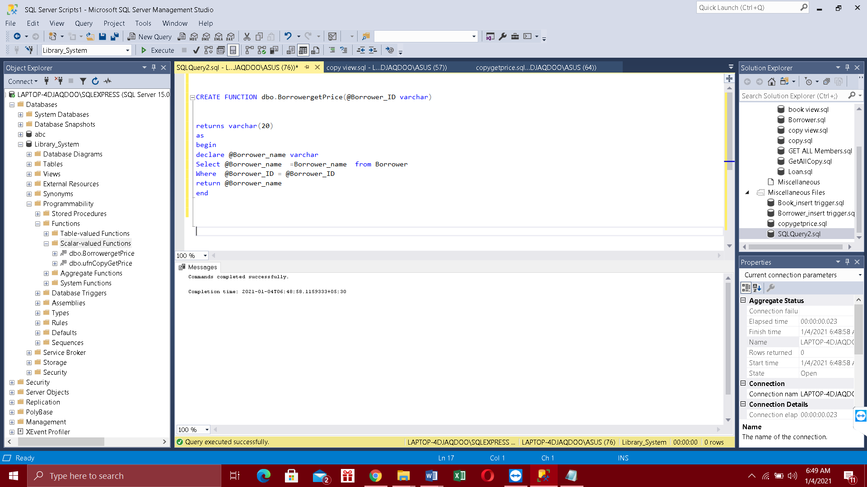

# Work load Matrix

|  |  |  |  |  |  |  |
| --- | --- | --- | --- | --- | --- | --- |
| Index number | ER diagram | Relational  Mapping | Normalization and data dictionary | SQL | Procedures, Functions | Triggers and  views |
| 10707202 | yes |  |  | yes |  |  |
| 10707362 |  | yes | yes |  |  |  |
| 10707193 |  |  | yes |  |  | yes |
| 10707375 | yes |  | yes |  | yes |  |
| 10707428 |  | yes |  |  | yes |  |
| 10707297 |  |  |  | yes |  | yes |